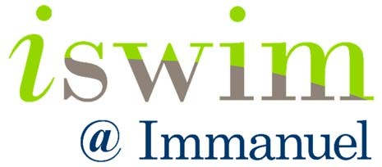
Ukraine Community Swimming Program Details Form

Please fill in all of the information below to help us place your child in the correct level in our Primary School Aquatic Program.
Child’s name _____________________________________________________ Age _____

 | Yes/No |  | More information
My child has never swum or had swimming lessons
My child is comfortable putting their face in the water
My child can do torpedos and is comfortable on their back in shallow water
My child is comfortable in deep water where they cannot touch the bottom
My child can swim basic freestyle for 10m
My child can swim basic backstroke for 10m
My child can swim backstroke and freestyle comfortably for 25m
My child is an advanced swimmer and comfortable at distances of 50m or more without stopping
My child currently does swimming lessons |  | Swim school:  Level:
Medical Information pertaining to swimming:
Information contained in the following section will not preclude your child from swimming lessons, unless further medical advice warrants exclusion.

Medical Condition | Yes/No | Special instructions
Epilepsy
Periodic loss of consciousness
Heart condition
Ear disorder
Asthma
Allergies
Other relevant information:

I am the Parent/Guardian and give permission for my child __________________________________to participate in the Primary School Swimming and Aquatics Program

Signed __________________________________________ Date __________

